**Higher Diploma in Computing – Part-Time 2014**

**Semester 3**

**Course Module: Software Engineering for Web Applications**

**(**HDC-SEWA)

**Main Assignment – ER Diagram**

**Student Names: Gavin McGovern, Frank Deasy, Cathal Mulkere**

**Student ID Nos.: 2862213, 2864260, 2859287,**

**Lecturer: Mark Scanlon**

**Date Due: 05-01-2015**

Introduction

GFC-Stats.com is happy to present the first version of a new and website with a lot of potential. Having reviewed current offerings on the web in relation to statistics available on various sports a perceived gap exists in the market for a site targeted at sportspeople on which they can record and compare their performance in both training and matches against their peers and competitors.

An interactive website prototype has been developed initially GAA football players but with scope to translate to other sports. Users are able to record data relating to their daily training and match activities under a number of criteria onto a database that will allow them identify key aspects of their training and performances against others in their field. This comparison will be displayed by way of graphs and tables making it clear where more effort is needed and where they compare favourably to their competition.

Design Layout

Our understanding on the design layout is that we are to develop the site using HTML, CSS, Java Script and MySqli only. Thus we were unable to use tools such a Bootstrap and JQUERY as well as more formalised tools. These limitations refined certain aspirations we had on the functionality of the site and how we would like it to present. Thus while researching the design options we found that the majority of the more popular sites tend to create a customised format though shades of grey appear to be more popular for physical training sites. In an effort to keep the site crisp and clear we decided to use these base colour on our site.

For the prototype we have included 4 key pages.

1. A home page which explains the reason for and benefits of the site.
2. About us page which explains the details of the project in question, the people behind it and also explains how the site works for interested users and the likely outcomes they can achieve.
3. Contact us page gives details of how to make contact with us through the various media and a location map of where to find us. We have also included and enquiry form here where users can submit specific enquires rather than email.
4. Analysis page. This is the page where the user can actually start to interact with the site. To do this they must first register.

Registration

There is a short form that each user must fill out which includes details to fill their profile. Once registered they can enter the Analysis section and begin to use the site.

Analysis

The user can input their training data for each day they train and their match data for each match played. Once they have done this they will be able to compare their performance against the database and see how they compare. Ideally we would like this analysis to develop further to capture more information but initially we wanted to keep the time needed inputting data to a minimum so kept the forms short yet useful. Creating future links to download data from some of the tools available on the market would allow greater input and more relevant results.

Assumptions

We initially populated the database with player data from a number of inter-county players to create a base from which to compare inputs. Although the specific data isn’t accurate it correlates with the targets and schedules of best practice in the sport.

Site Map Diagram:

Below is a breakdown of the site map.

Wireframe Diagram:

Home Page

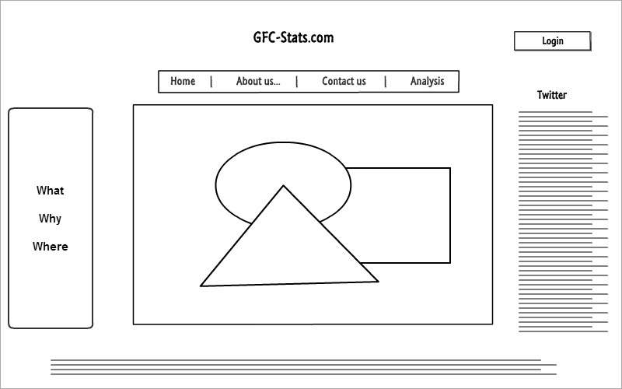

About us

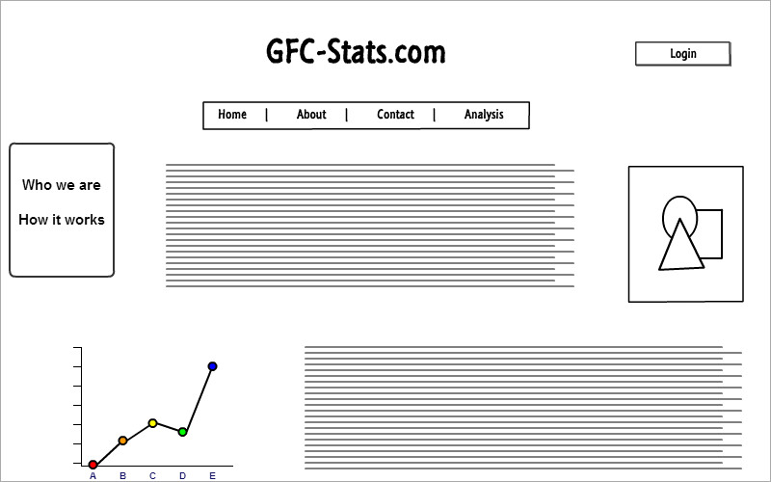

Analysis Page

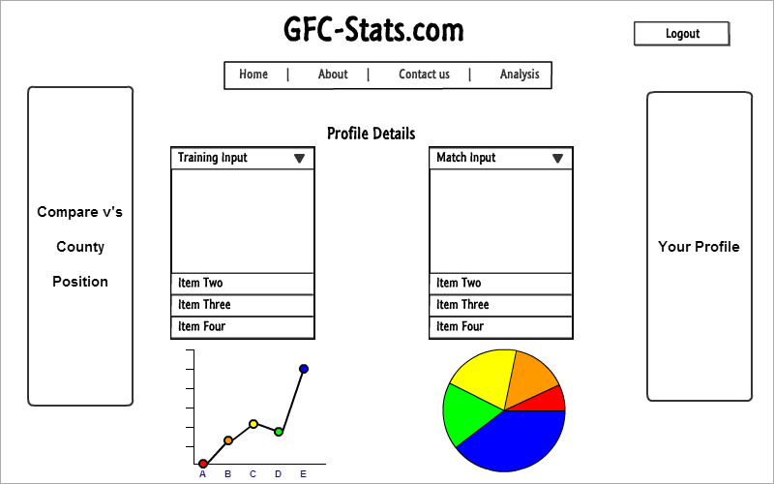

Research Sites

